Supplemental data
Figure S1
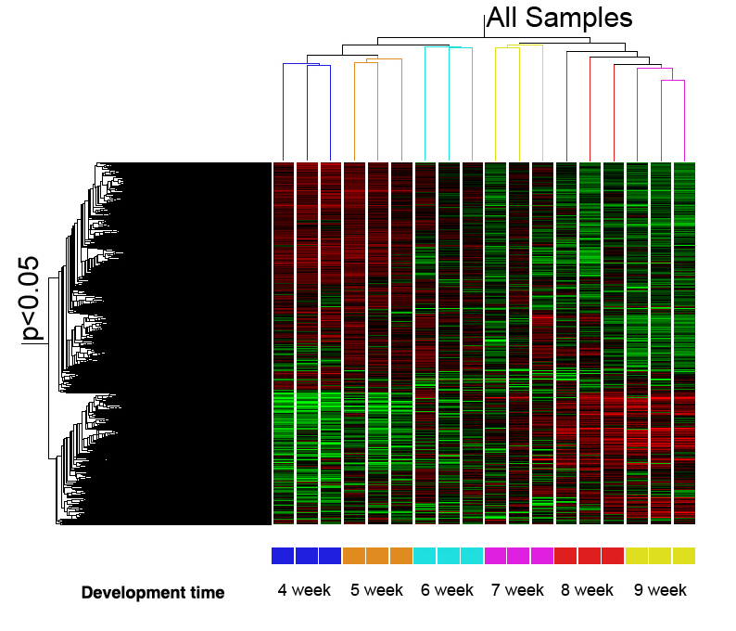
Figure S2
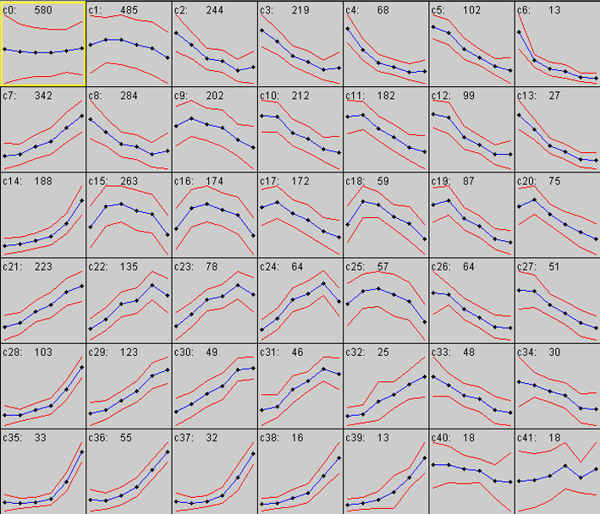
Figure S3
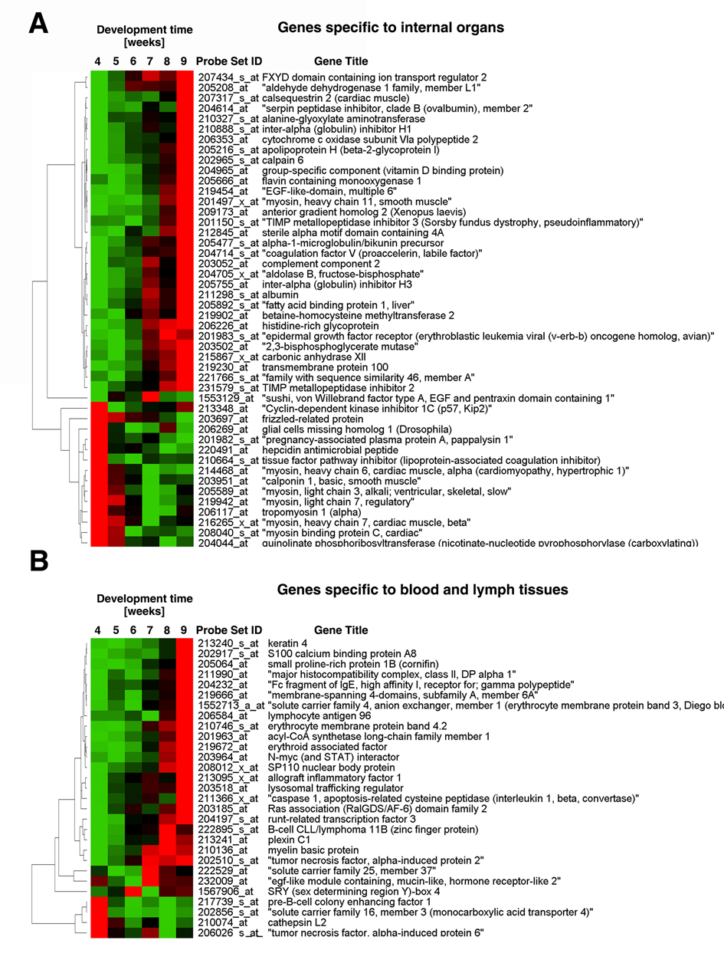
Supporting Figure Legends
Figure S1 (related to Figure 1). Clustering of the gene expression profiles of the 18 individual embryo cDNA arrays showing that the microarray gene expression profiles clustered according to the developmental stages of the embryos.
Figure S2 (related to Figure 2). SOM cluster analysis of the developmentally regulated genes. The expression profile of each gene was normalized to have a mean value of zero and a variance of one, and the normalized profiles were placed into 42 clusters. The labels for each panel indicate the index of the cluster in the full SOM (c0-c41), followed by the number of genes in the cluster.
Figure S3 (related to Figure 4). Gene expression profiles of the genes, from the 5,358 regulated ones, that are associated with the indicated organ/tissues. They were presented according to the similarity of the expression pattern. (A) Genes specific to internal organs; (B) Genes specific to blood and lymph tissues.

